**Tanaka, Atsuko (田中 敦子)**

**(10 February 1932, Osaka – 3 December 2005, Nara)**

Atsuko Tanaka was a leading figure in Gutai, which counted more women among its members than any other group in Japan’s art world. Yet, she stood apart from some of her male counterparts, who were not shy of stripping down to loincloths and using their bodies and paintbrushes much more gesturally to proclaim inner feelings of freedom, jubilation or angst. She retreated from subjective expression and concealed her body from public view, so as to explore the interface between the physiological and technological.Her most pivotal work, *Electric Dress* (1956), consists of a robe covering the body from head to toe with a mesh of wires and flashing incandescent tubes and bulbs painted in all colours. This was either installed, or worn in performances, not just by Tanaka but others as well. Inspired by the post-war metropolis’ neon advertising, this was one of the first plug-in art-works incorporating artificial light. *Electric Dress* generated a prolific and diverse body of paintings, drawings and objects, in which Tanaka developed her artistic ‘signature’: dazzlingly colourful all-over webs of abutting and overlapping spheres, linked by meandering lines.

In 1950, Tanaka enrolled in the Art Institute of the Osaka Municipal Museum, where she befriended fellow students Kazuo Shiraga and Akira Kanayama (her future husband). With them, she formed Group Zero in 1953, moving away from figurative painting and embracing abstraction. Around 1955, they entered the orbit of Gutai, and would participate in its exhibitions till 1965. Tanaka had already been gravitating toward Gutai’s performative use of everyday objects with her experiments in collage, as in her work *Calendar* ( c. 1954) and a sound installation of 1955 called *Work (Bell)*, which was environmental and durational, bringing movement and sound into the audience’s experience. With Gutai, she showed her first fabric pieces – large rectangular or circular sheets of rayon pinned to walls or suspended above the ground, whose vibrant colours flouted Japanese aesthetic decorum. These experiments led to wearable art-works like *Stage Clothes* (1957), which could be performed in happenings, this saw the artist transforming her appearance through layers of textile artifice.

For Tanaka, painting and performance were not separate, but coextensive, both celebrating in the spirit of Gutai, the spontaneous naiveté of children’s creative expression. Too lyrical for the schematic diagrams of electronic engineers that they otherwise bring to mind, her painting reveals a ceaseless experimentation. It made use of different materials like acrylic, vinyl, Plexiglas, plywood, and even rotary motors in the case of *Spring* of 1966, and found its way into sculptural friezes, the windows of a book publisher’s office building in Tokyo, as well as the landscape. Taking her mark-making to a new level, the 16 millimetre film *Round on Sand* (1968) made with the assistance of the cameraman Hiroshi Fukuzawa,documented the artist performing a ‘drawing’ with a stick on the beach.

**Further Reading:**

Kato, M. and Tiampo, M. (2004) *Electrifying Art: Atsuko Tanaka 1954-68*, Vancouver: Morris and Helen Belkin Gallery.

Kato, M., and Watkins, J. (2011) *Atsuko Tanaka: The Art of Connecting*, Manchester: Cornerhouse Publications.

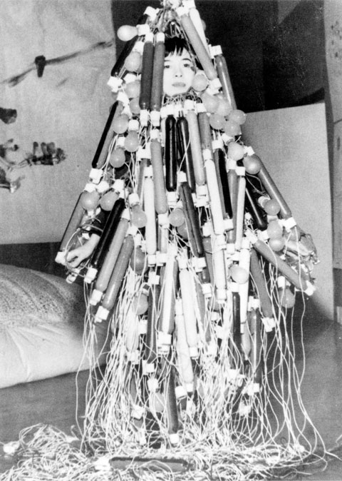

Atsuko Tanaka, *Electric Dress*, 1956, Ashiya City Museum of Art and History.